## Milestones

Milestone 1: UI/UX and Basic User Authentication

- Design Mobile App Interface (UI) — Owen

- Research and Integrate User Authentication Methods — Owen

- Design Registration Form Interface — Owen

- Develop User Database Structure — Andrew

Milestone 2: Backend Server Architecture and Real-Time Communication

- Develop Backend Server Architecture — Andrew

- Document Backend Server Setup and Communication Protocols — Andrew

Milestone 3: Sensor and Parking Spot Detection System

- Test Parking Spot Detection Systems (Motion/Infrared Sensors) — Andrew

- Investigate Sensor Technologies for Detecting Vehicles — Andrew

Milestone 4: GPS Integration and Parking Spot Location

- Specify Parking Spot Location Method Using GPS — Andrew

- Test GPS System Integration — Andrew

- Validate Parking Location Method with Field Tests — Andrew

Milestone 5: Real-Time Data Processing and System Refinement

- Refine Real-Time Data Fetching Process for Parking Availability — Andrew

- Design System for Processing and Updating Parking Spot Data in Real Time — Andrew

- Test Real-Time Server Communication Between App and Database — Owen

Milestone 6: Security and User Data Management

- Specify Security Measures for Protecting User Data — Owen

- Document User Authentication and Database Interaction Process — Owen

Milestone 7: User Experience and Testing

- Test the Mobile App UI Components — Owen

- Validate User Experience Through User Testing Sessions — Owen

Milestone 8: Advanced Data and Sensor Integration

- Research Data Analysis Methods for Sensor Data Processing — Andrew

- Test Data Analysis System for Parking Availability Updates — Andrew

Milestone 9: Scalability and User Feedback

- Assess Database Scalability for Increasing Users — Andrew

- Develop User Feedback Loops for Reporting Parking Issues — Andrew

Milestone 10: Completion and Documentation

- Develop User Guides and Tutorials — Owen

- Document System Processes and Protocols for Future Maintenance — Owen and Andrew

## Timeline

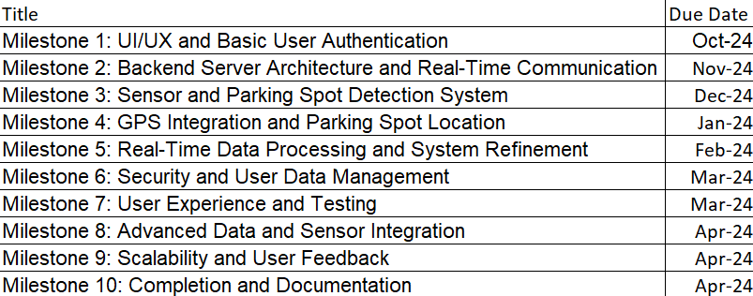

Tabe 1: Timeline of Project

## Effort Matrix

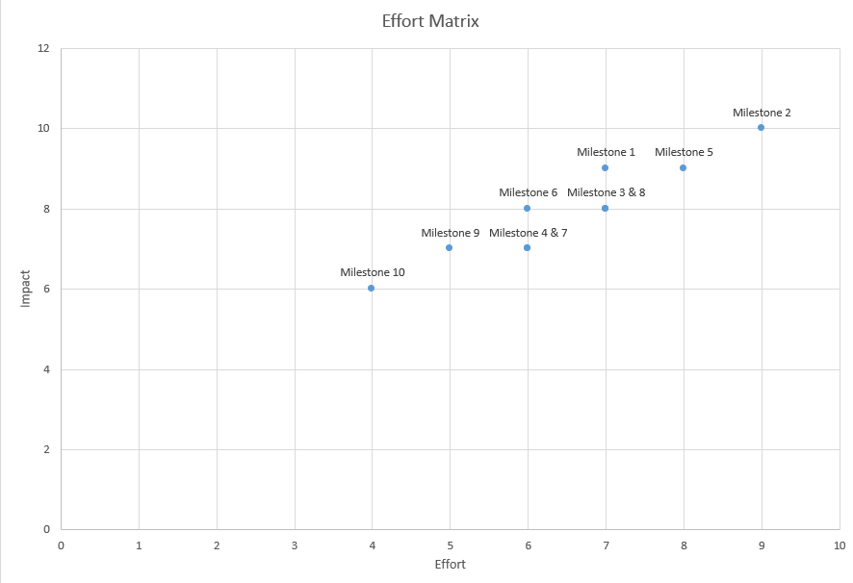

Table 2: Effort Matrix of our Milestones